Operators in Python
Last updated on September 17, 2020

In this lesson, we will learn about expressions and various operators provided by Python.
Operator: An operator is a symbol which specifies a specific action.
Operand: An operand is a data item on which operator acts.
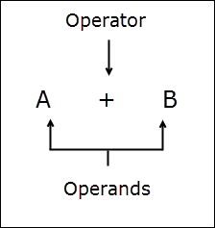
Some operators require two operands while others require only one.
Expression: An expression is nothing but a combination of operators, variables, constants and function calls that results in a value. For example:
1  2  3  4  5  6  7 | ## some valid expressions  1 + 8  (3 * 9) / 5  a * b + c * 3  a + b * math.pi  d + e * math.sqrt(441)

